Date: 3rd October 2024 |  |  | Class: 9X2
Lesson Objective:
To be able to balance symbol equations

Big picture (Medium term plan, national curriculum, responding to formative data):

Last lesson we recapped learning on constructing word equations. This lesson also builds upon the fundamental idea that mass is conserved in chemical reactions (hence the need for balancing)
After this lesson, every time there is a chemical equation in a topic pupils will need to apply this learning. For example, when we move onto rates of reaction next week, they will need to balance the equations for the rate reactions.
This also links to balancing respiration/photosynthesis equations in biology.
This lesson is fundamental to more challenging parts of chemistry (mole calculations), etc. So whilst there are balancing questions in the assessment, this lesson is much more important than just exam success.
I need to be careful not to introduce misconceptions around ionic compounds being discrete molecules.

Completed independent task/You (including annotated thinking process):

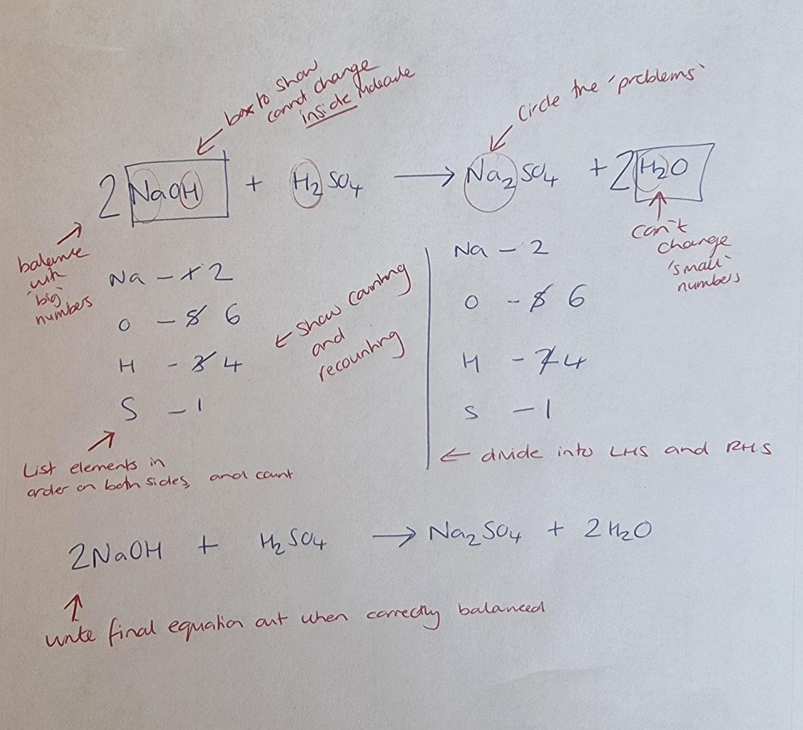

Misconceptions to be aware of:

- You can change the ‘little numbers’ (coefficient vs subscript)- this is underpinned by the misconception that :
- Compounds are viewed as being formed by simply sticking fragments together, rather than as being created by the breaking and reforming of bond

TKT & TBAT:
- To know that Cl₂ shows a molecule of chlorine containing 2 chlorine atoms, H₂O shows a molecule of water containing 2 hydrogens and 1 oxygen.
- To know that the little numbers can’t be changed in a formula as it changes the substance (e.g. H₂O is water but H₂O₂ is hydrogen peroxide)
- To know that no elements are created or destroyed in a chemical reaction (all atoms present in the reactants must be accounted for in the products)
- To know the steps to balance equations: (1) write out equation (2) draw line to separate reactants from products (3) count up atoms present on each side (4) trial and error to balance
To know helpful tips for balancing (unusual elements first, leave oxygen till the end)

# of I, We, CfU, You cycles: 2
Which TKT/ TBAT will you cover in each cycle?
- First I, We, CfU, You: 1,2
- Second I, We, CfU, You: 3,4,5
Lesson part | TKT/ TBAT | Description (inc. scripting and use of other adults where appropriate) |  | Time
Do Now |  | P: Enter in silence and answer 5 do now questions (+ extension)  T: Greet at door (“do now’s on the board. Start in silence). Give out ‘cheat sheet’ to AC. Circulate when all pupils are working in silence  Cold call to go through do now (MT, AK, HH, AKi, BA)  Hands up for extension.  Expected answers appear on board (animation). Pupils self-correct.  Looking for:  - Pupils remembering both products, not just the one they have to work out  Pupils remembering water is produced if oxygen is present, carbon dioxide if carbon is present, hydrogen if only hydrogen present. |  | 5 mins
Hook |  | Image of unbalanced atoms in an equation- turn and talk- what is the problem here? |  | 1 min
Intro (introduce, sequence, importance, enthuse) |  | Today we’re going to be building on our work from yesterday on word equations to start working as actual chemists work – using symbol equations. (Show word equation from do now + its symbol equation). Symbol equations are incredibly helpful to chemists because they don’t just show the reactants and the products (hydrochloric acid reacting with magnesium to produce water and magnesium chloride), they show how much of each reactant you need and how much product you get. By the end of the lesson you will be able to work out these big numbers to balance equations (point to big numbers). You won’t have to memorise the formula like MgO – today, you’ll be told them. But in future lessons I will teach you how to work them out yourself!  This lesson is one of the most important lessons in chemistry – in every lesson after this, whenever we have a reaction (so most lessons), we will also work out the balanced symbol equation. You’ll even use this in your biology lessons when you write the balanced symbol equation for photosynthesis! |  | 2 mins
I | 1,2 | Model how to work out which elements are present and how many.  Steps to unpicking a formula:  - Find the first element by looking for capital letters and find the element name on the periodic table  - Check to see if there is a little number next to the symbol. If there isn’t a number, it means there is one (chemists are lazy). If there is a little number, it tells you how many of that element are present.  - Move onto the next element and repeat.  Script:  Before we move onto balancing equations, our first step is to be really confident to know what each of these formulae tell us.  We have to be really careful with our formulae because they tell us everything we need to know. For example we have H2O and H2O2. What’s H2O? (take hands – water). But H2O2 is hydrogen peroxide, which is bleach – great for dying your hair, but not so great for drinking!  For example, when we see Li2SO4, which elements are present and how many of them? I’m going to model for you how I would work this out. Then we’ll have a go together, have a look at some common errors, practise on mini-whiteboards and then you’ll practise on your own.  Ok so here’s my first formula. It’s MgCl₂. The first think I’m going to do is identify how many elements I have. Sometimes I’ll recognise the elements, but I can always look at the capital letters. Every element contains only one capital letter. So looking at this formula, I have Mg (emphasise M) and Cl (emphasise C). My next step is to check the names of the elements using my periodic table. Hmm ok, so let me look at my periodic table for Mg. (model scanning across the giant periodic table on the wall). Ah. Here it is! Mg is Magnesium. Now I need to check how many Magnesiums there are so I need to look for little numbers. There isn’t a little number next to Mg so that tells me that there is just one. Scientists are lazy so don’t bother writing a little 1.  So now I can write: 1 Magnesium.  Now I can just repeat this with my other element. First I need to find Cl on the periodic table. Hmmmmm. Cl…… Ah. Cl is chlorine. I need to check how many chlorines there are. Oooh there’s a little number just here. It says ‘2’ so I know there are 2 chlorines. So I’ll write 2 chlorines. |  | 6 mins
We | 1,2 | I do, you help:  Let’s do one together. (CC = Cold Call)  I have LiF₂. My first step is to check how many elements I have. What do I use to help me do this?  CC: AC  Ans: Look for capital letters  Yes. So how many elements do I have? (still AC).  Ans: 2  What’s the symbol for the first element?  CC: EJa  Ans: Li  Ok so you now have 20secs to try and find Li on the periodic table.  CC: AK  Ans: Lithium  Great. Am I done?  CC: MT  Ans: No  What do I still need to do? (still MT)  Ans: Check little numbers  Ok so is there a little number next to the Li?  CC: HH  Ans: No  So what does that tell me (still HH)?  Ans: There’s one.  Great, so I can write 1 lithium.  With your partner, repeat this process for the other element in this formula. You have 45s.  CC: HN  Ans: 2 Fluorines.  Common errors:  Have a look at this pupil’s work (H2SO4 – hydrogen, sulphur, oxygen). Talk to your partner for 30s. What mistakes have been made?  CC: Hja  Ans, They’ve missed the numbers. Should be 2 Hydorgens, 1 Sulfur, 4 oxygens  Now look at this one. What mistakes have been made?  (H2O – 1 hydrogen, 2 oxygens). 20s with your partner. Go.  CC: Aki  Ans: It’s 2 hydrogens and 1 oxygen?  Follow up qu:  So what did this pupil get confused about?  Ans: they thought the little number was before the element.  Follow up: And what do we know?  Ans: the little number is after the element it’s referring to |  | 5 mins
CfU | 1,2 | 5 mini-whiteboard questions  - Cl₂  - H₂O  - H₂O₂  - Fe₂O₃  - K₂SO₄ |  | 5 mins
You | 1,2 | You now have 6 mins on your own to complete the worksheet.  Cold call to go through answers. |  | 6 mins to complete  3 mins CC/self mark
I | 3,4,5 | Model Balancing equations |  | 7 mins
We | 3,4,5 | Complete another example together as a class (I do, you help) |  | 5 mins
CfU | 3,4,5 | Mini white board to check all pupils |  | 5 mins
You | 1-5 | Students complete question 1-5 balancing equations on their own |  | 10 mins
Exit Ticket | 1-5 | 3 key questions |  | 5 mins
Homework |  | Worksheet on compounds and balancing equations- due next Wednesday
Resources needed

